AWS Certificate Manager (ACM)
Amazon Web Services provides a service called AWS Certificate Manager (ACM).
AWS ACM helps users create, manage, and renew SSL/TLS certificates easily.
These certificates are used to:
- Secure websites
- Enable HTTPS
- Encrypt data between users and applications
- Build trusted and secure communication

What is SSL/TLS?
SSL (Secure Sockets Layer) and TLS (Transport Layer Security) are security protocols used to encrypt communication between:
- User browser
- Web server/application
Example:
- HTTP → Unsecured
- HTTPS → Secured using SSL/TLS certificate

Why ACM is Used?
Without ACM:
- Users must manually buy certificates
- Upload certificates
- Renew certificates before expiry
With ACM:
- AWS provides free certificates
- Automatic renewal
- Easy integration with AWS services

Services That Use ACM
ACM can be attached to:
- Elastic Load Balancing
- Amazon CloudFront
- Amazon API Gateway
- AWS Elastic Beanstalk

Real-Time Use Case

Scenario
- A company hosts a web application on AWS.
Users access:
http://myapp.com
The company wants:
- Secure communication
- HTTPS enabled
- Browser trust
- Data encryption
Solution:
- Create SSL certificate in ACM
- Attach certificate to Load Balancer
- Access application using HTTPS
Final URL:
https://myapp.com

Architecture:
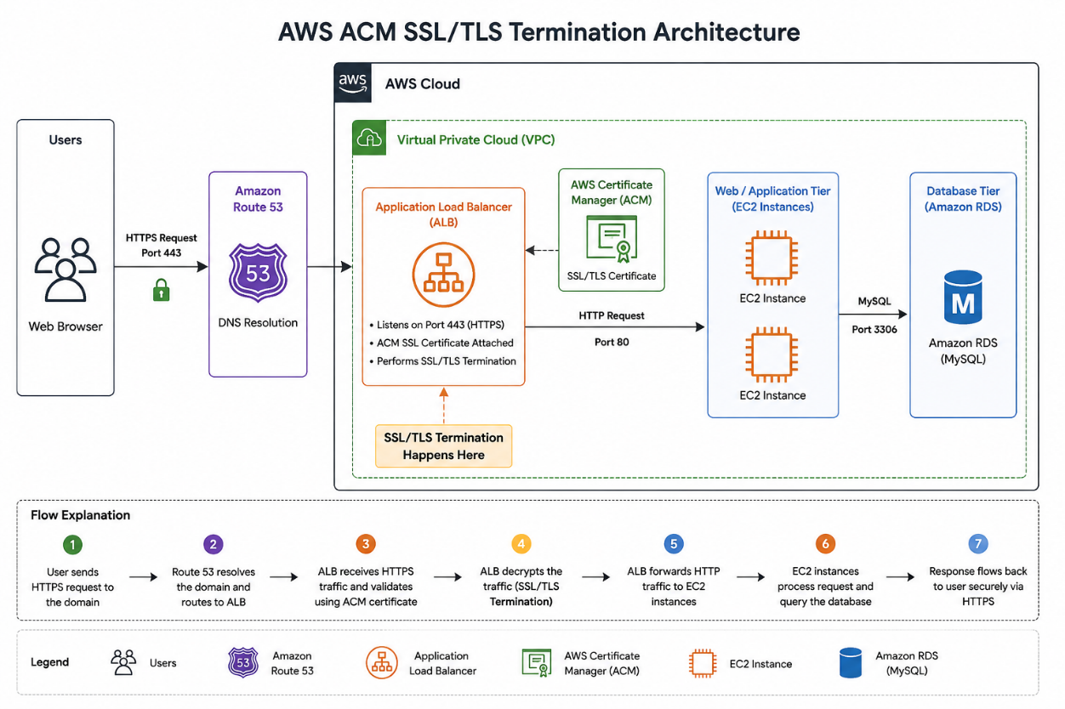

Architecture Flow:
User Browser
↓
HTTPS Request
↓
Application Load Balancer
(ACM SSL Certificate Attached)
↓
Web/Application Server
↓
Database

Benefits of ACM:
Feature | Benefit
Free SSL Certificates | No extra cost
Automatic Renewal | No downtime
Easy Integration | Works with AWS services
Secure Communication | Encrypts data
Trusted by Browsers | Avoids security warnings

ACM Implementation Steps (End-to-End):

Step 1 — Login to AWS Console
Open:
AWS Management Console
Login using AWS account credentials.

Step 2 — Open AWS Certificate Manager
Search:
Certificate Manager
Open:
AWS Certificate Manager

Step 3 — Request a Public Certificate
Click:
Request a certificate
Select:
Request a public certificate
Click:
Next

Step 4 — Add Domain Name
Enter your domain name.
Examples:
myapp.com
Or
*.myapp.com
Wildcard (*) means all subdomains.
Example:
app.myapp.com
test.myapp.com

Step 5 — Select Validation Method
Choose:
DNS Validation

Why DNS Validation?
- Easier
- Recommended by AWS
- Automatic renewal support
Click:
Request

Step 6 — Validate Domain Ownership
ACM provides:
- CNAME record
- Name
- Value
Go to your DNS provider:
- Route 53
- GoDaddy
- Namecheap
- Cloudflare
Add the CNAME record.
Example:
Type | Name | Value
CNAME | _abc.myapp.com | xyz.acm-validations.aws

Step 7 — Certificate Issued
After successful validation:
Status = Issued
Now certificate is ready to use.

Step 8 — Attach Certificate to Load Balancer
Go to:
EC2 → Load Balancers
Select:
Application Load Balancer
Edit Listener:
HTTPS : 443
Attach ACM certificate.
Save changes.

Step 9 — Configure Security Group
Allow:
HTTPS → Port 443
Security Group Rule:
Type | Port
HTTPS | 443

Step 10 — Test HTTPS
Open browser:
https://myapp.com
Now:
- Connection is secure
- Browser shows lock icon
- Data is encrypted

SSL Termination / TLS Termination

What is SSL/TLS Termination?
SSL/TLS termination means:
- Encryption is handled at the Load Balancer
- Backend servers receive normal HTTP traffic
Why SSL Termination is Used:
Reason | Benefit
Reduce EC2 workload | Better performance
Centralized certificate management | Easier maintenance
Easier scaling | Useful for Auto Scaling
Simplified backend | No certificate installation on each server

ACM with Application Load Balancer

Components Used:
Component | Purpose
ACM | SSL certificate
ALB | Handles HTTPS
EC2 | Hosts application
Route 53 | Domain management

Final Conclusion:
AWS ACM simplifies SSL/TLS certificate management by:
- Providing free certificates
- Automating renewal
- Enabling HTTPS security
- Integrating easily with AWS services
It helps organizations secure applications with minimal operational effort.

